NAME: K Yamini
REG NO: 192572181

Write a Python program for the Vacuum Cleaner problem.
Aim:
To simulate a simple intelligent vacuum cleaner agent that cleans a given environment.
Algorithm:
- Define the environment with two locations (A and B).
- Each location can be either Dirty or Clean.
- Place the vacuum cleaner in one location.
- Check the current location status:
If Dirty → Clean it
If Clean → Move to the other location
- Repeat until both locations are clean.
- Display each step with action performed.
Python Code:
# Vacuum Cleaner Problem
# Environment
environment = {
'A': 'Dirty',
'B': 'Dirty'
}
# Initial location
location = 'A'
# Function to print environment
def print_env():
print("Location A:", environment['A'])
print("Location B:", environment['B'])
print()
print("Initial Environment:")
print_env()
step = 1
# Loop until all clean
while environment['A'] == 'Dirty' or environment['B'] == 'Dirty':
print("Step", step)
if environment[location] == 'Dirty':
print("# Location", location, "is Dirty → Cleaning")
environment[location] = 'Clean'
else:
print("# Location", location, "is Clean → Moving")
# Move to other location
location = 'B' if location == 'A' else 'A'
print("# Moved to Location", location)
print_env()
step += 1
print("All locations are clean!")
Input:
Initial State:
Location A = Dirty
Location B = Dirty
Starting Position = A
Output :
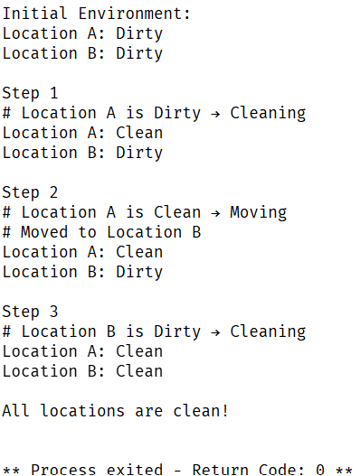
Result:
The Vacuum Cleaner problem is successfully simulated, and the agent cleans all dirty locations using simple reflex actions.

